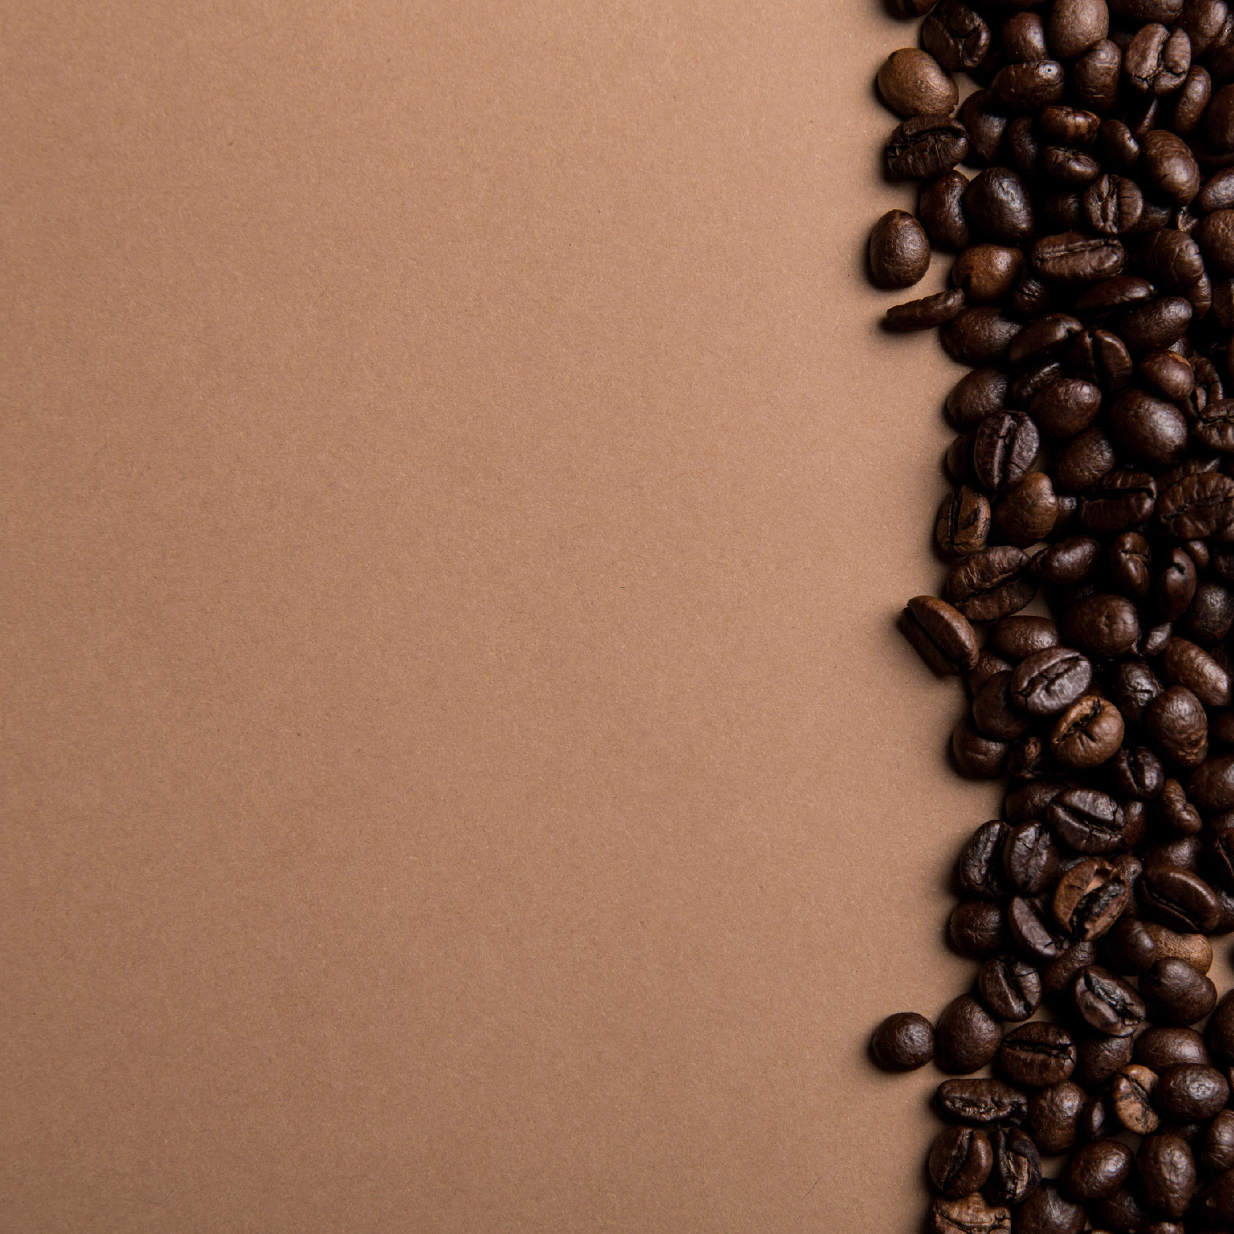

The main objective of

this project is to analyze

retail sales data to gain

actionable insights that

will enhance the

performance of the

Coffee Shop.

Start Your Day With Coffee



How do sales vary by day of the

week and hour of the day?

Are there any peak times for sales

activity?

What is the total sales revenue for

each month?

How do sales vary across different

store locations?

what is the average price/order

per person

Which products are the best-

selling in terms of quantity and

revenue?

How do sales vary by product

category and type?

Recommended Analysis

**ANALYSIS OF COFFEE SHOP**

1. **Sales Variation by day of the week and hour of the day -**

* **Days of the week** – Sales throughout the week with the highest sale on

Monday ($101,677.28) & FRIDAY ($101,373.00) and with the lowest sale on Saturday ($96,894.48)

* **Hour of the day** – The sales as per the hour of the day has been clearly show in the chart. Maximum Sales has every time reached to the peak of (10) then it slowly declines.

1. **Peak times for sales activity –**

* Peak days – Monday and Friday are the peak days for the sale
* Least sales – Saturday has the least sale

**3.Total Sales Revenue for Each Month –**

|  |  |
| --- | --- |
| MONTHS | REVENUE |
| January | $81,677.74 |
| February | $76,145.19 |
| March | $98,834.68 |
| April | $118,941.08 |
| May | $156,727.76 |
| June | $166,485.88 |

(Sales from January to June shows a steady increase in the Revenue)

1. **Sales Variation Across Different Store Locations –**

|  |  |
| --- | --- |
| STORE | REVENUE |
| Astoria | $232,243.91 |
| Hell's Kitchen | $236,511.17 |
| Lower Manhattan | $230,057.25 |

(Hell’s Kitchen has highest Sales followed by Astoria and Lower Manhattan)

1. **Average Price Per Order & Per Person –**

* Average Bill - 4.69
* Average Order - 1.44

**6.Best Selling Products Based on Quantity and Revenue –**

* Coffee $269,952.45
* Tea $196,405.95
* Bakery $82,315.64

**7.Sales Variation By Product Category And Type –**

|  |  |
| --- | --- |
| **Product Category** | **Revenue** |
| Bakery | $82,315.64 |
| Branded | $13,607.00 |
| Coffee | $269,952.45 |
| Coffee beans | $40,085.25 |
| Drinking Chocolate | $72,416.00 |
| Flavors | $8,408.80 |
| Loose Tea | $11,213.60 |
| Packaged Chocolate | $4,407.64 |
| |  |  | | --- | --- | | Tea |  | | $196,405.95 |

|  |  |
| --- | --- |
| **Product Type** | **Revenue** |
| Barista Espresso | $91,406.20 |
| Brewed Black tea | $47,932.00 |
| Brewed Chai tea | $77,081.95 |
| Gourmet brewed coffee | $70,034.60 |
| Hot chocolate | $72,416.00 |

**Conclusion –**

The analysis of the Coffee Shop's sales data reveals key insights into customer behavior and trends. Sales are highest on Mondays and Fridays and lowest on Saturdays. Monthly sales show a steady increase from January to June, with June having the most sales.

Among the locations, Hell's Kitchen has the highest sales, followed by Astoria and Lower Manhattan. The average bill per order is $4.69, with customers buying an average of 1.44 items per order, suggesting room for increasing sales per customer.

Coffee is the top-selling category, bringing in the most revenue, followed by tea and bakery items. Barista Espresso, Brewed Chai Tea, and Gourmet Brewed Coffee are the

best-selling products. The shop should focus on promoting these popular items and look for ways to boost sales of less popular ones.